**ASSIGNMENT: -05**

**EECE: -212**

**NAME: Shaharehar Rahaman Anik**

**Level: 2**

**ID No: 201916058**

**Here are some mathematical problem are solved by MATLAB 2020a.according to the questions. The answers are given bellow:**

**Question:**

**(x, y) = (1, -15.997), (2, -19.808), (3, -21.813), (4, -15.712), (5,14.875), (6,103.968), (7, 312.947) Find the first and second derivative of the interpolated curve at x = 6 and x = 7. Use backward difference method.**

**Solution:**

Here given some value of a function=(0.00.3 x^6 -4x -12) against the value of x. Now I have to find the 1st derivative and 2nd derivative of the interpolated curve at x=6 & x=7.The programs are given bellow.

**When x=6:**

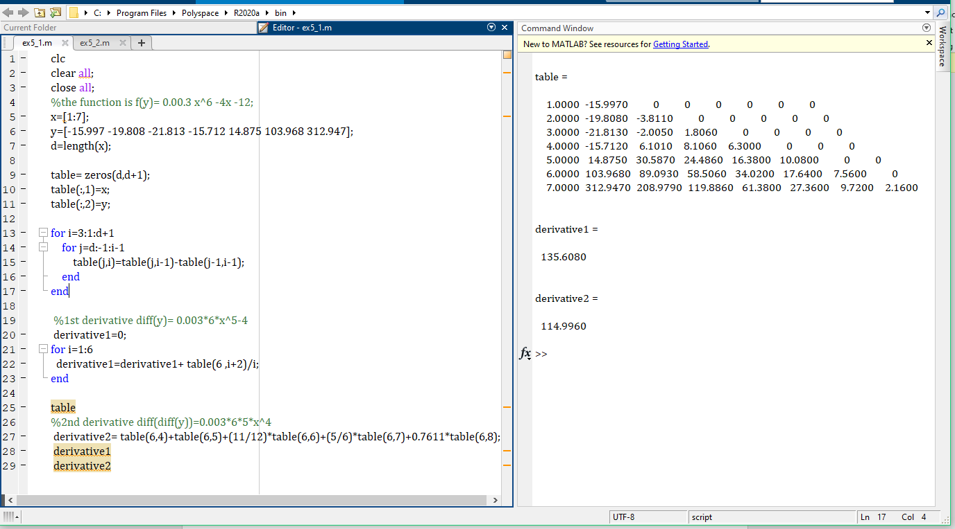

**Here,**

1st derivative is 135.6080

2nd derivative is 114.9960

Here point to be noted that in backward function, in the decreasing of the value of x the accuracy of the value is also decreased.

So, when x=6

The value of 1st derivate is 135.6080.

But,

The accurate value is:

diff(.003*x^6-4*x-12);

= 0.003*6*x^5-4

=135.968.

**The accuracy is**: $\frac{135.6080}{135.968}x100=99.73\%$

Again, the value of 2nd derivative is 114.9960.

But,

The accurate value is:

diff (diff (0.00.3 x^6 -4x -12))

=0.003*6*5*x^4

=116.64

**The accuracy is**: $\frac{114.9960}{116.64}x100=98.59\%$

**When x=7:**

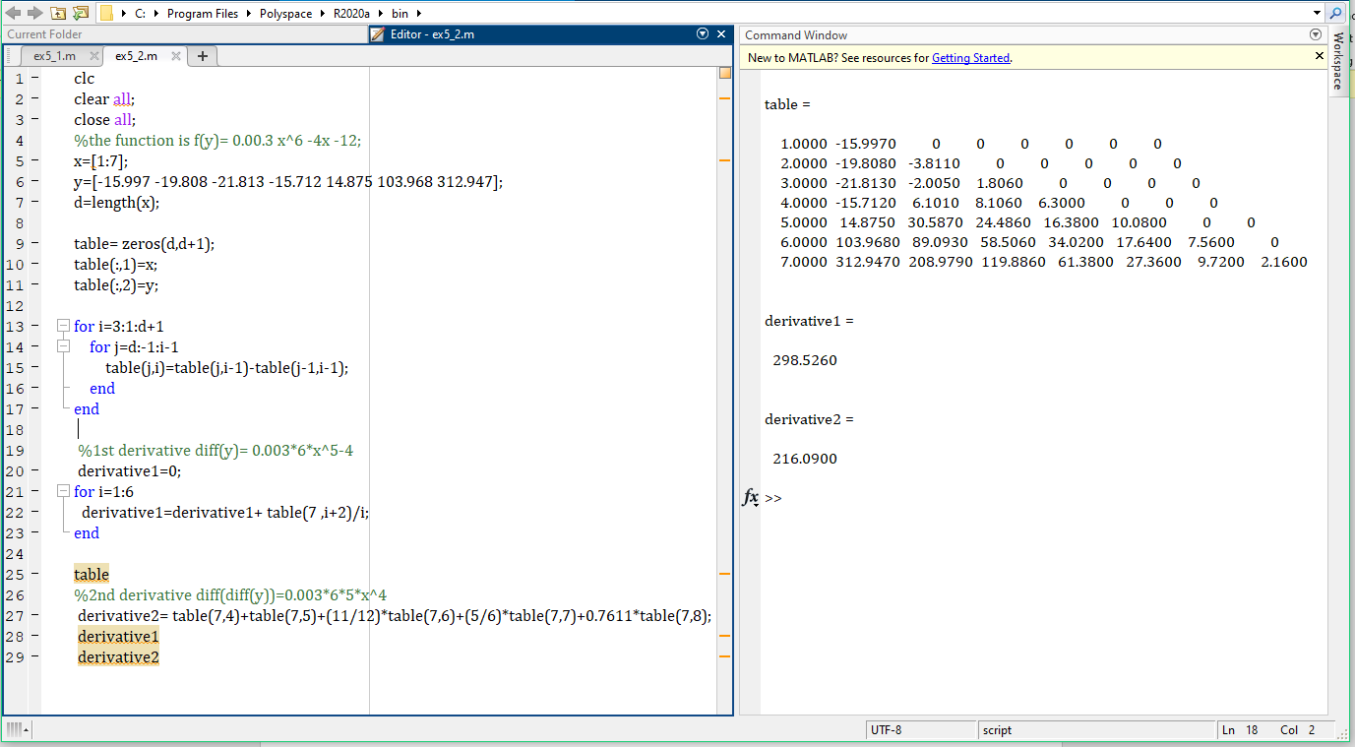

**Here,**

1st derivative is 298.5260

2nd derivative is 216.0900

As x=7 is the last value of backward function so it is fully accurate is the program value.